1. **Introduction**

**Background**

In this paper, I will be looking at the eight boroughs in Amsterdam and analyzing them based on a few key variables. Amsterdam has been around since the [13th century](https://en.wikipedia.org/wiki/History_of_Amsterdam), yet the current eight boroughs are rather recent. It wasn’t until May 1st of 2010 that the [15 boroughs](https://nl.wikipedia.org/wiki/Amsterdam_(gemeente)#Indeling_in_stadsdelen) in Amsterdam were condensed down into the 8 that they are now (see Figure 1 below). Amsterdam is a huge tourist attraction for many reasons: the canals, museums, famous painters, architecture… and of course the coffee shops and Red Light District… but it is also a very densely populated city with over 800,000 residents living in these eight boroughs. That averages out to about 100,000 residents per borough, which is especially impressive given the relatively small size of each borough (the biggest borough is 49km2 while the smallest is only 8km2!)

**Figure 1: Amsterdam’s Districts**

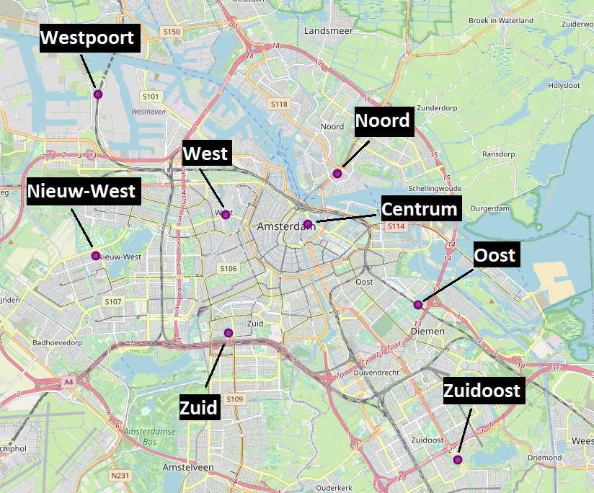

**Problem**

This leaves us with a problem though: how can a tourist best spend their time in Amsterdam? Surely, you want a place that has many interesting venues in the vicinity, but you also want to try and avoid crowds as much as possible (especially now that COVID-19 is such a serious threat), so where do you go? Given this problem, I think it would be interesting to look at Amsterdam and see if its high population density and number of venues is in any way correlated to the overall safety ratings of each borough, so as to hopefully find the best place to stay that has 1) many venues and attractions nearby 2) not too many people around and 3) a low crime rating.

**Interest**

But who would be interested in this? Well, literally anyone thinking of visiting the city, of course! Granted, it might not be happening anytime soon, given the pandemic, but once travelling becomes safer again, a lot of people will be hopping on planes again, jetting off to all corners of the world. Where will the people visiting Amsterdam go to stay? Perhaps this paper might shed some light on that for them. I think this is of interest even to people currently living in Amsterdam already, too. Imagine you are living in the city’s center: it is way too busy for you and crime is higher than you might like, but would moving to a district be the right choice? Would you be giving up access to too many venues? Perhaps the other neighborhoods are even less safe… This right here is an excellent way to find out those answers!